

KENKEN Puzzle

***Course Code:* CSE481**

***Course Name:* Artificial Intelligence**

**Ain Shams University**

**Faculty of Engineering**

**Spring Semester – 2022**

**Student Personal Information**

|  |  |
| --- | --- |
| 1700923 | عمرو ايهاب عبدالعزيز محمد عبدالعزيز |
| 1700903 | عمر محمد عمر عبدالسميع |
| 1601166 | محمد خالد سيد ابراهيم مهران |
| 1700918 | عمرو احمد محمد فتحى محمد |
| 1701043 | لؤي عبدالله يوسف عبدالهادي |
| 1700907 | عمر محمد محمد مصطفى |

# GitHub Repo Link

<https://github.com/AmrAhmed11/kenken-puzzle-solver>

# Performance Analysis

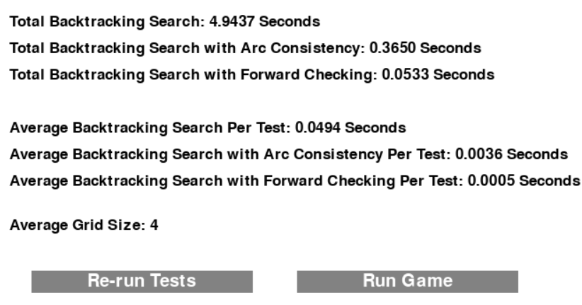

We run the three algorithms on 100 randomly generated boards with random sizes from 2 to 6. The speed ranks:

1. Backtracking search with forward checking.
2. Backtracking search with arc consistency.
3. Backtracking search.

# Class diagram

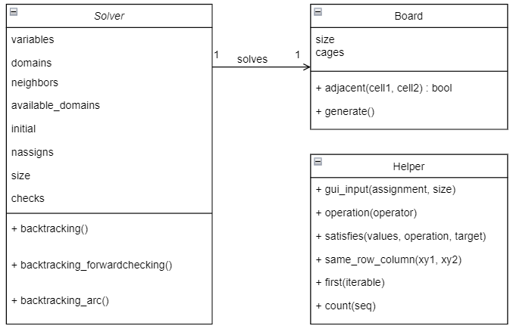

# Data structures

**Board** is represented as a list of tuples. Each tuple represents a cage. The cage tuple has 3 fields

The first one is a tuple of tuples. Each one represents the coordinates of a cell that belongs to the cage.

The second field is a character that represents the operation used in the cage (+, -, *, /, .)

The third field is an integer that represents the target result of the cage.

An **Assignment** is represented as a dictionary, there is a key for each cage on the board.

The key is a tuple of tuples, where each of them is a coordinate of a cell in the cage.

The value is a tuple of the values of each cell in the cage.